Accessibility Guide for New Place Hotel

sales@newplacehotel.com, 01329 833543, www.newplacehotel.co.uk
Contact for accessibility enquiries: Alex McCann

We aim to confidently ensure that all our guests have comfortable facilities, all requests are dealt with efficiently and everyone is made to feel welcome throughout their stay. As far as possible we will accommodate the requirements of all our guests. We will explain our facilities and how they may meet guests’ requirements.

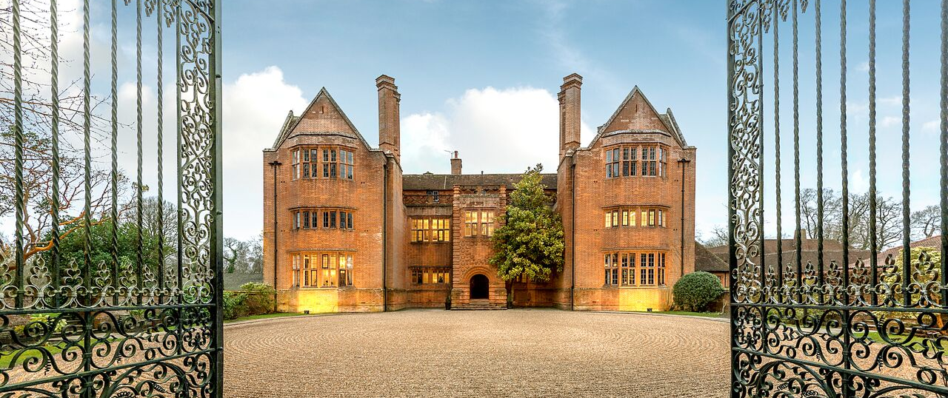

Welcome
New Place is a stunning hotel and conference venue in Southampton, ideally suited for meetings, events, weddings, and leisure breaks. New Place, Southampton seamlessly blends traditional and modern spaces over 32 acres of landscaped gardens, including our Grade I listed manor house which houses a restaurant, a bar and meeting rooms.
Enjoy every modern convenience and amenities with all our bedrooms located in a delightful mews a short walk from the manor house and set against a backdrop of relaxing English countryside. You’ll have plenty to do during downtime with a gym, pool, croquet lawn, and cricket pitch on the property.

Although we have tried to be as accurate and include as much detail as we can in our Access Statement, we are always willing to give information on any aspect of the hotel if this statement does not answer your query.

Parking
- There is parking surrounding the venue. There are accessible parking spaces – 1 outside reception, 2 outside block 3, 2 outside Arden suite.
- The parking is less than 50 metres from the main entrance. Parking is free of charge.
- There is a drop-off point at the main entrance.
- From the car park to the entrance, there is level access. There is permanent ramp access to our manor house.
- There are free designated car parking spaces next to the hotel reception and by the bedrooms.

Arrival

Path to main entrance – reception (management centre)
- From the street to the main entrance, there is level access.
- There is a permanent ramp into our manor house.
- The path is 3000mm wide, or more.

Main entrance – reception (management centre)
- The main entrance has level access.
- The main door is side hung.
- The door is 1000mm wide, or more.

Reception
- All ground floor doors are open during normal service hours.
- There is level access to the main reception.
- The reception area has seating for guests to wait
- When checking-in, reception staff will note if guests will need assistance in the event of an evacuation and this forms part of the night porter brief.

Public rooms in the hotel
- The whole of the ground floor of New Place Hotel is level and accessible to wheelchairs – as is much of the surrounding garden including the terrace and courtyard.
- The hotel bars are on the ground floor – there is a moveable ramp to access the bar.
- All corridors and public areas are well lit.
- All doors and corridors are wide enough for wheelchairs/zimmer frames/pushchairs.
- There are disabled toilets on the ground floor that are suitable for wheelchairs and has a baby-changing facility.
- All diets can be catered for although advance notice is helpful.
- There is a ramp to access the 2 steps up to the Restaurant.
- High chairs are available and may be used in all areas.
- The restaurant lighting is even but can be varied using dimmer switches.
- Dogs including service dogs are allowed in the hotel.
- We can provide water bowls for assistance dogs on request.
- Door frames and doors are painted contrasting colours to the walls in the public areas.
- Wi-Fi is available Free of Charge throughout the public rooms and the bedrooms.

Meeting rooms
- Wi-Fi is accessible in our meeting rooms using a bespoke code which will be issued by the conference manager on arrival.
- Private dining is available in all our meeting rooms.
- There are male and female toilets accessible from the Meeting Rooms and a disabled toilet is available on the ground floor.

Management Centre
The ‘Classroom 6, 5, 4, 3, 2’ rooms and ‘Syndicates 1, 2, 3’ are all on the ground floor and accessible via level access from Reception.
The Stratford Suite, Stour and Avon Rooms are located on the 1st floor of our management centre. It is usually accessed via a staircase which may prove difficult for those with mobility restrictions. There isn’t a lift within this building.

Manor House
The Cressida, Ophelia, Brutus & Falstaff rooms with additional syndicates are located on the 1st floor of our manor house. The Horatio, Portia, Yorick & Shylock rooms with additional syndicates are located on the 2nd floor of our manor house.
These are all accessed via a staircase which may prove difficult for those with mobility restrictions. There isn’t a lift within this building.

The Court / Arden Suite
The Court and The Arden Suite are both on the ground floor and accessible via level access from the car parks and reception.

Bedrooms
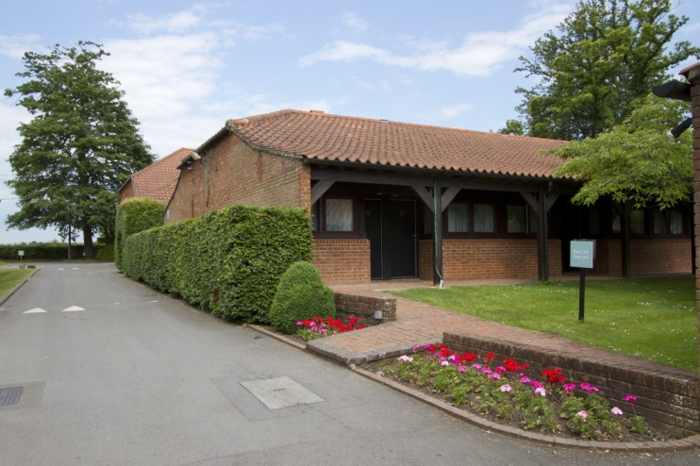
- Of the bedrooms, there are four ground floor Garden Rooms which are suitable for those with restricted mobility. These can be single occupancy, twin or double-bedded.
- There are two ground floor rooms with level shower access.
- We have a direct dial telephone, an audio alarm that is activated by the fire alarm and smoke alarms in every bedroom.
- The bedrooms and bathrooms are generously proportioned but some provide more turning and transfer space than others.
- We try as far as possible to allocate bedrooms based upon individual guest needs.
- Emergency procedures are posted on the door to each bedroom and are explained upon check in for any disabled guests upon request.
- Every bedroom has digital television with remote control.
- There are bedside lights.
- All of our bedding is non-allergenic.
- All rooms are non-smoking in compliance with current legislation.
- Furniture within the rooms can be moved.
- Every bedroom is carpeted.
- Bedroom lighting can be switched on at the entrance to the room and within the room.
- Non-slip floor shower mats are available upon request
- Bathroom lighting is very bright, and all sanitary ware is white.

Getting around outside

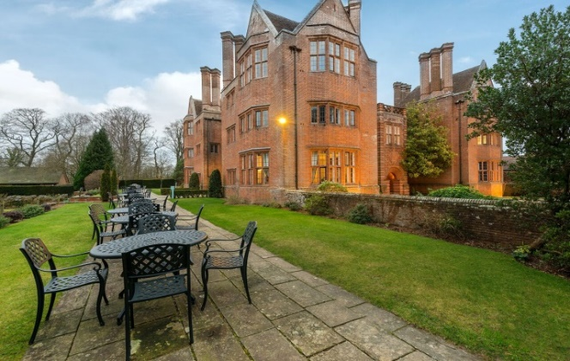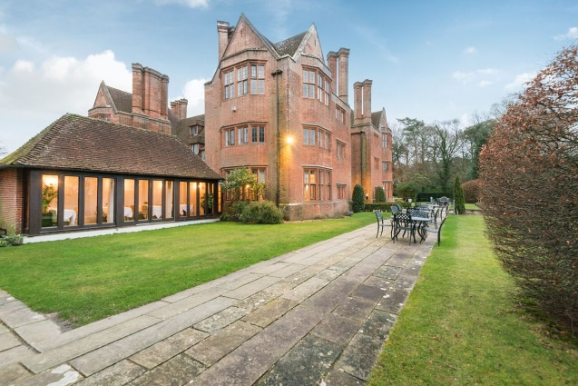
- From the main entrance to this area, there is level access via a permanent ramp.
- From the rear of the house to the Gardens there is a sloped ramp.

Hearing
- The fire alarm has flashing lights.
- We have a hearing loop at reception and in our Arden Suite.
- Some staff have disability awareness training.

Emergency evacuation procedures
- We have emergency evacuation procedures for disabled visitors.
- The fire alarm has flashing lights.

Getting here
New Place Hotel, High Street, Shirrell Heath, Southampton, SO32 2JY

Travel by public transport
- You can get to New Place Hotel by bus.
- The nearest bus stop is on Winchester Road called ‘Church Road’. The bus stop is 0.3 miles / 0.4 km from New Place Hotel.
- There are a selection of buses which connect us to Wickham Square, No. 691, to Fareham and Winchester, No. 69.
- You can get a taxi with 24/7 Taxis by calling 01329 235235. The taxi company has a wheelchair accessible vehicle.

